**A4 Assignment**

**CS5800**

**Jonah Kubath**

**Summary**: Assignment 4 is building a DFA simulator. The program is given the transition table and final states. An input string is then simulator with the given transitions. ACCEPT or REJECT is then output for the string.

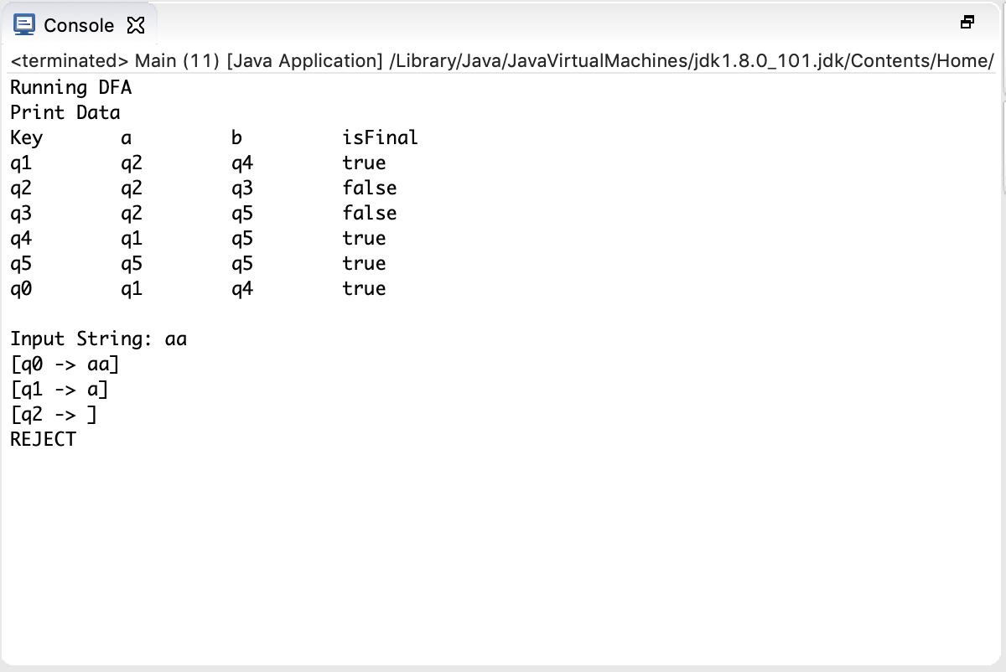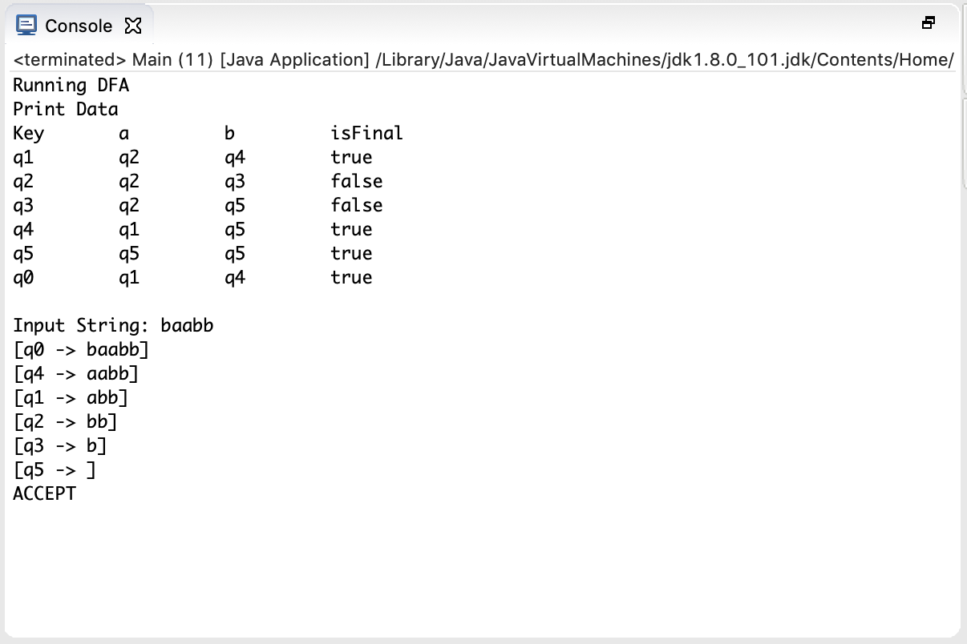**Results**: The results that I received not very flashy. The transition table is straight forward in the rules. I included a few pictures of my run results.

**Compilation**: I have compiled a JAR file that can be run with the Java JVM. In terminal, navigate to my project directory:

JonahKubath_CS5800_A4

Then run the command:

Java -jar JonahKubath_A$.jar <filename>

The filename can be specified for to read from input. There are also default files that will be read if this is left blank.

The project can also be run inside of the Eclipse IDE. Open the project folder in Eclipse to run.